Roll the Dice Entity Relationship Diagram and Screenshots

|  |
| --- |
| Player |
| * Id long * username String * victories Integer * losses Integer * points Integer * reported Boolean * team Team * achievements Achievements |

|  |
| --- |
| Achievements |
| * Id long * title String * description String * complete Boolean |

|  |
| --- |
| Team |
| * Id long * teamName String * country String * memberCount Integer |

Main Menu

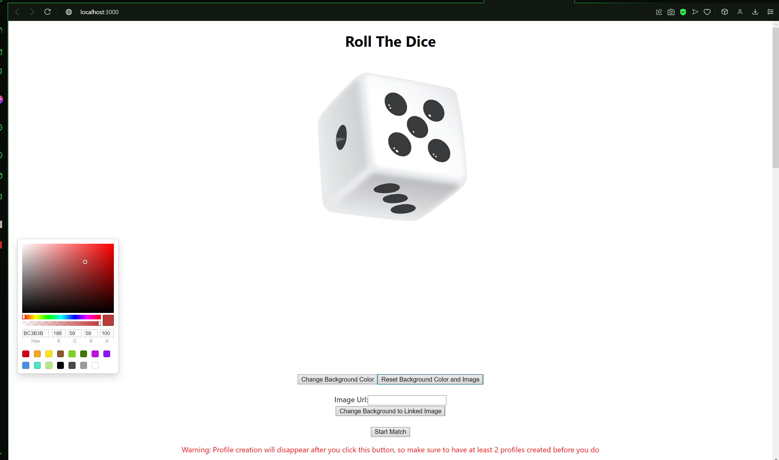

Adding a new profile

Creating a new Team and getting their members’ stats

Deleting and Renaming a Player

Picking Profiles to start a match

Match

Match Results

